Parameterized Build & Triggers

1. Under Jenkins Dashboard , Click on New_Item and create a new freestyle project and check the box which says “This project is Parameterized”

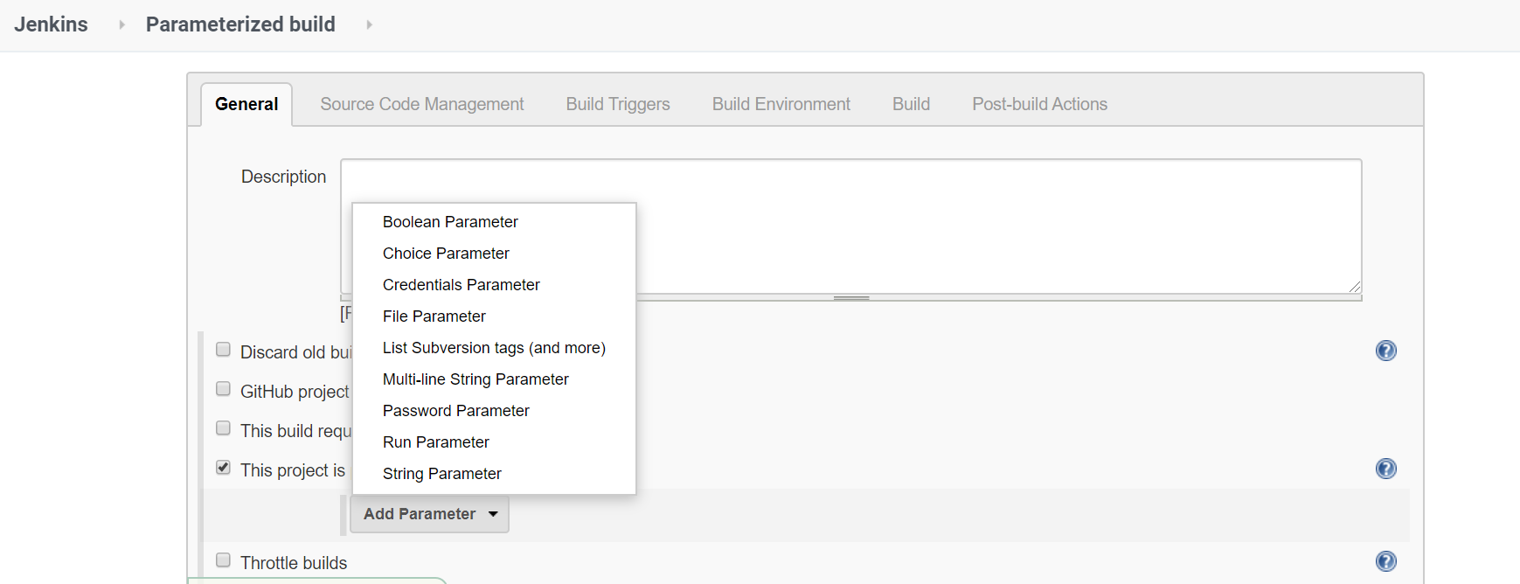

1. Choose String Parameter and provide the details as below and Click on Apply

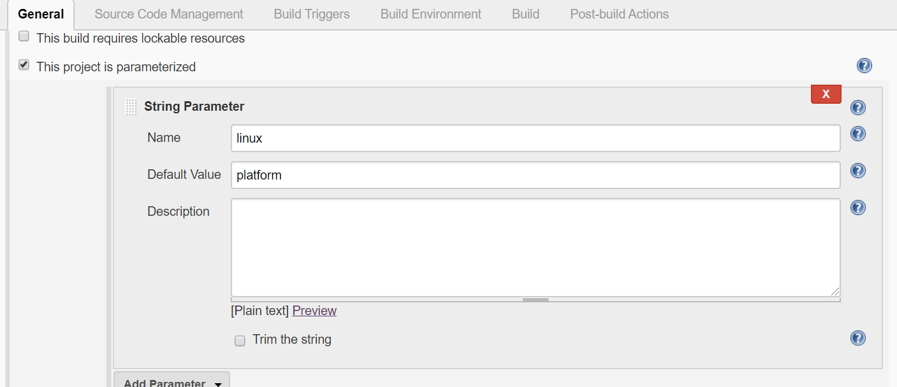

1. Now under Build Environment , choose Add Build Step and click on Execute shell option

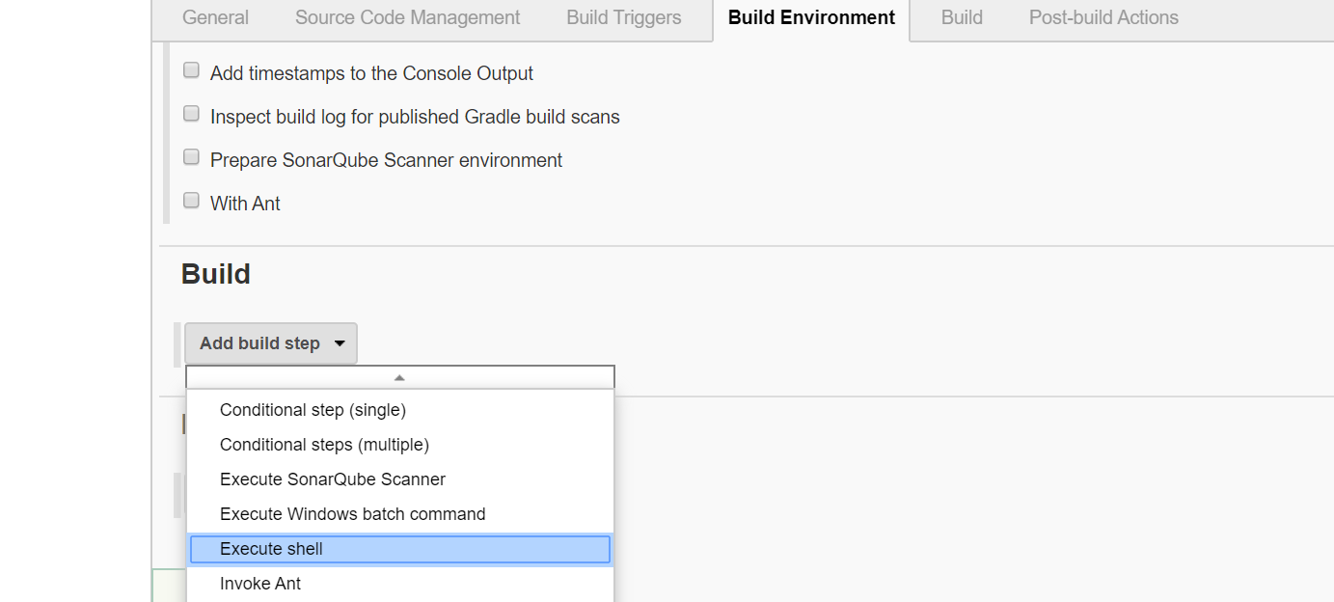

1. Enter the command echo $platform and Click on Apply.

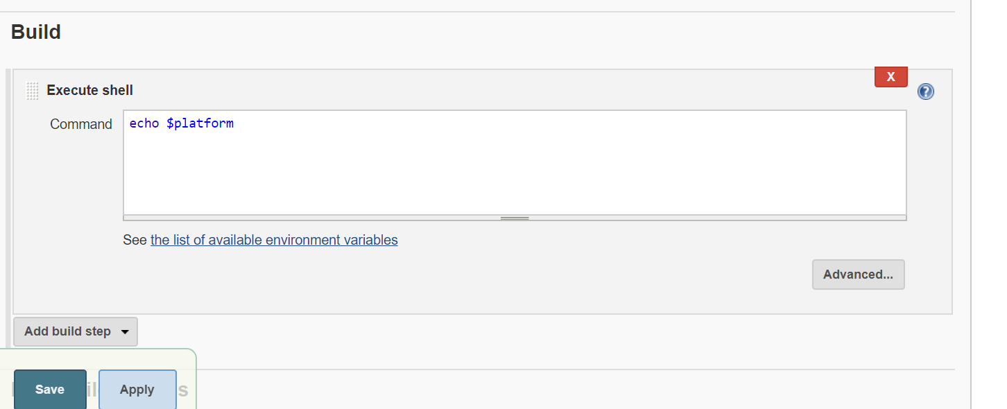

1. Add any other parameters like “Choice Parameter” and Apply.

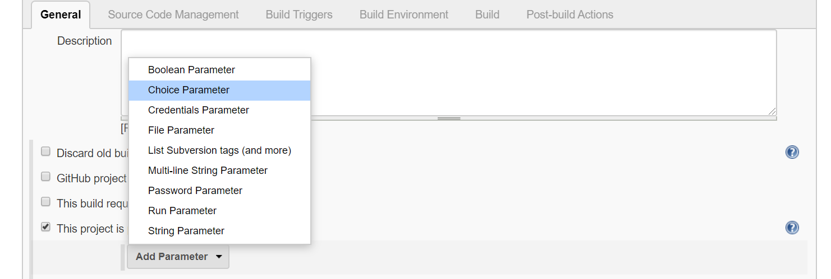

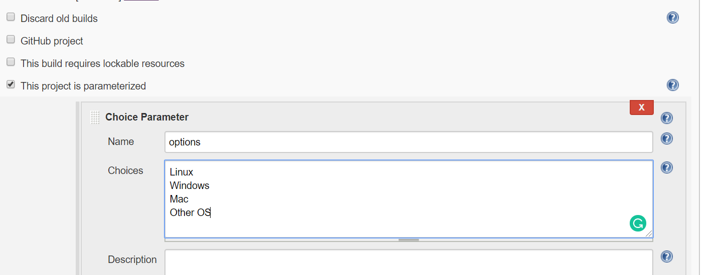

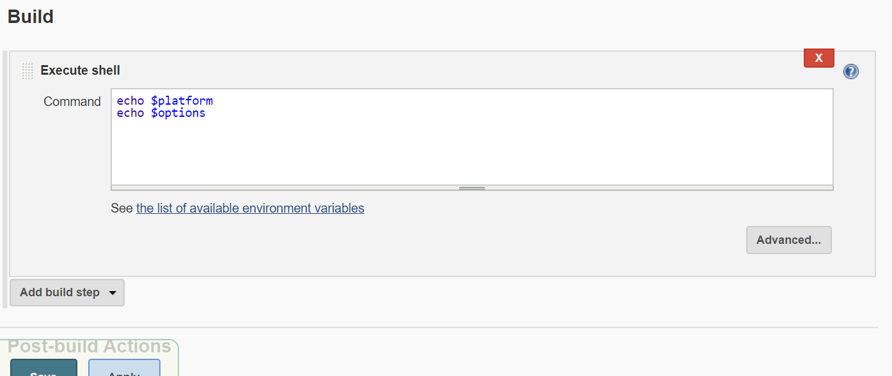

6. Now Under Jenkins Dashboard let us build the project by clicking on “Build with Parameters:

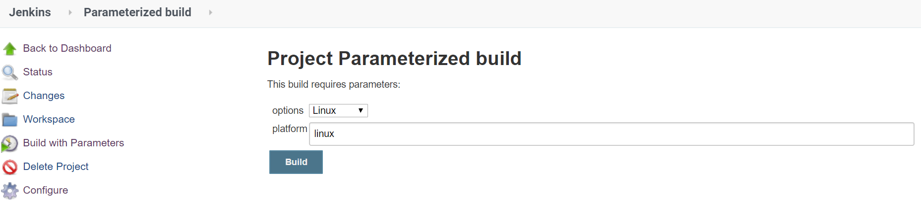

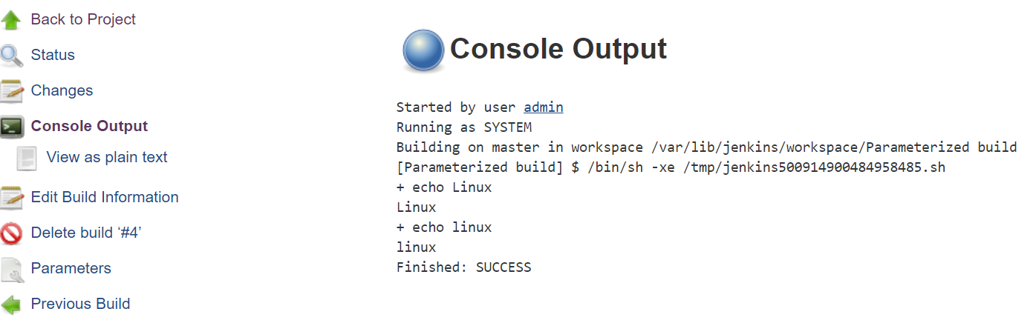

Parameterized Trigger

